**ASSIGNMENT 01:**

**Question 01:**

import java.util.*;

import java.io.*;

public class Main {

public static void main(String[] args)throws Exception {

Scanner t=new Scanner(System.in);

File a1=new File("tj.txt");

System.out.println("Enter your name = ");

String n=t.nextLine();

System.out.println("Enter your ID = ");

String i=t.nextLine();

System.out.println("Have you complete PF and oop(yes/no) = ");

String result=t.nextLine();

System.out.println("Enter your PF marks = ");

int p=t.nextInt();

System.out.println("Enter your OOP marks = ");

int o=t.nextInt();

try {

FileWriter f= new FileWriter("tj.txt");

f.write(n+"\n");

f.write(i+"\n");

char c =result.charAt(0);

if (p>=50 && o>=50 && c =='y'){

f.write("You can select Data Structure"+"\n");

}else{

f.write("You cannot select Data Structure");

}

f.close();

} catch (Exception e) {

System.out.println("Not Found");

}

try{

FileReader a2=new FileReader(a1);

BufferedReader b= new BufferedReader(a2);

String r;

while ((r= b.readLine()) != null){

System.out.println(r);

}

a2.close();

b.close();

}

catch (Exception e){

System.out.println("Not Found");

}

}

}

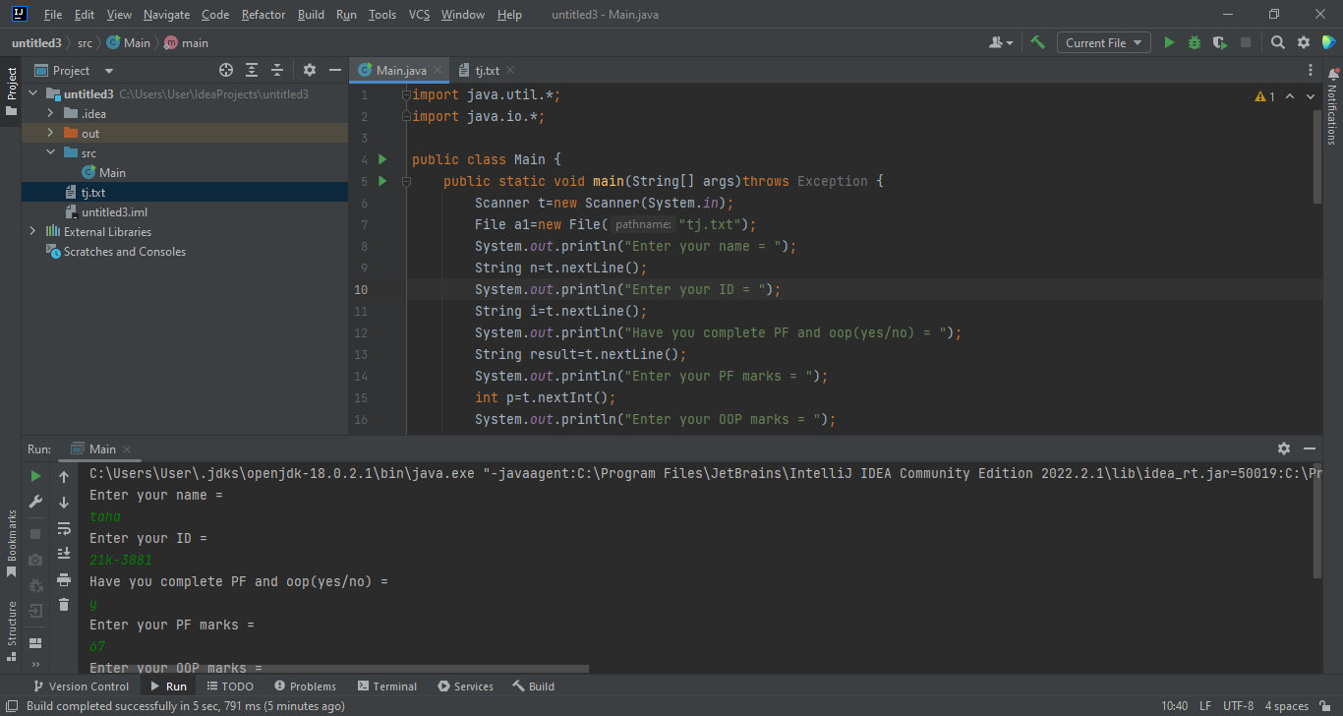

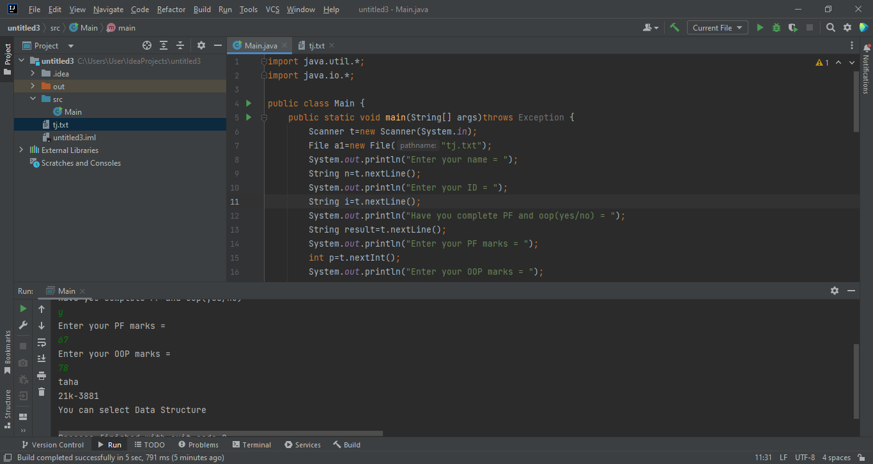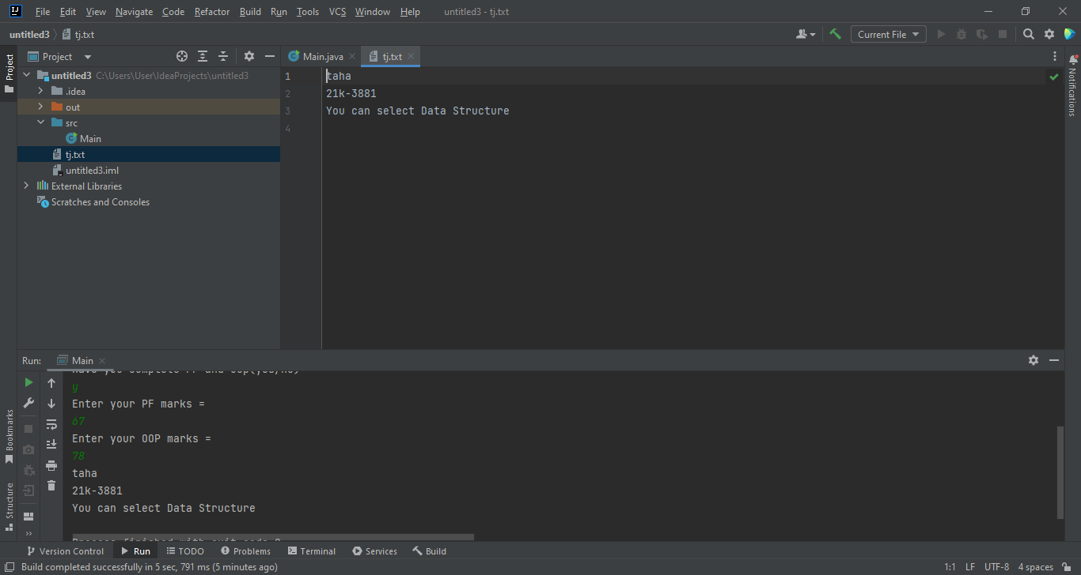

**QUESTION 02:**

import java.util.*;

import java.io.*;

public class Main {

public static void main(String[] args)throws Exception {

File a1= new File("tj.txt");

Scanner t=new Scanner(System.in);

System.out.println("Admin or a staff ?(A/S)");

String w=t.nextLine();

char q=w.charAt(0);

try {

FileWriter fw= new FileWriter(a1);

if (q=='a' ||q=='A'){

System.out.println("Name = ");

String n1=t.nextLine();

System.out.println("Department = ");

String d1=t.nextLine();

System.out.println("hours do you work in a week: ");

int hr=t.nextInt();

String p1=String.valueOf((hr*4)*1500);

fw.write(n1+"\n");

fw.write(d1+"\n");

fw.write(p1+"\n");

}

else if (q=='s' ||q=='S'){

System.out.println("Name = ");

String n2=t.nextLine();

System.out.println("Department = ");

String d2 =t.nextLine();

System.out.println("Hours do you work in a week: ");

int hr=t.nextInt();

String p2= String.valueOf((hr*4)*950);

fw.write(n2+"\n");

fw.write(d2+"\n");

fw.write(p2+"\n");

}

fw.close();

}

catch (IOException e){

System.out.println("File not found!!");

}

try {

FileReader fr= new FileReader(a1);

BufferedReader b=new BufferedReader(fr);

String r;

while ((r=b.readLine())!=null){

System.out.println(r);

}

fr.close();

b.close();

}catch (IOException e){

System.out.println("File not found !!");

}

}

}

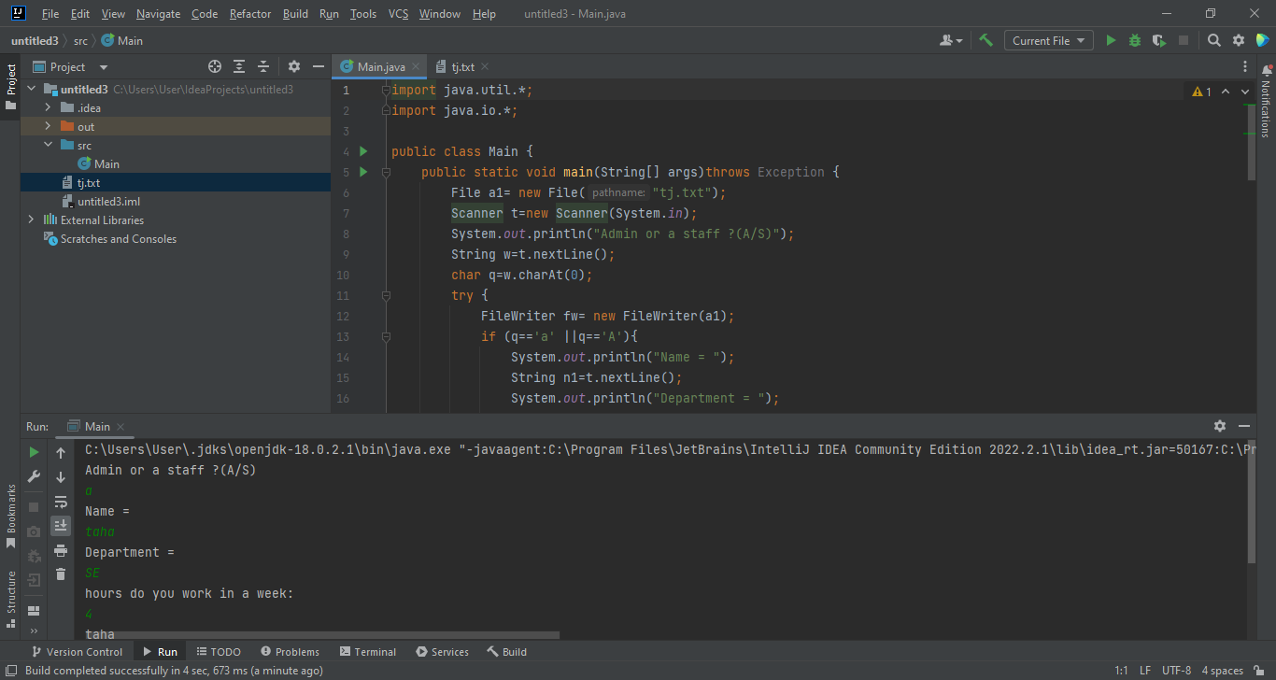

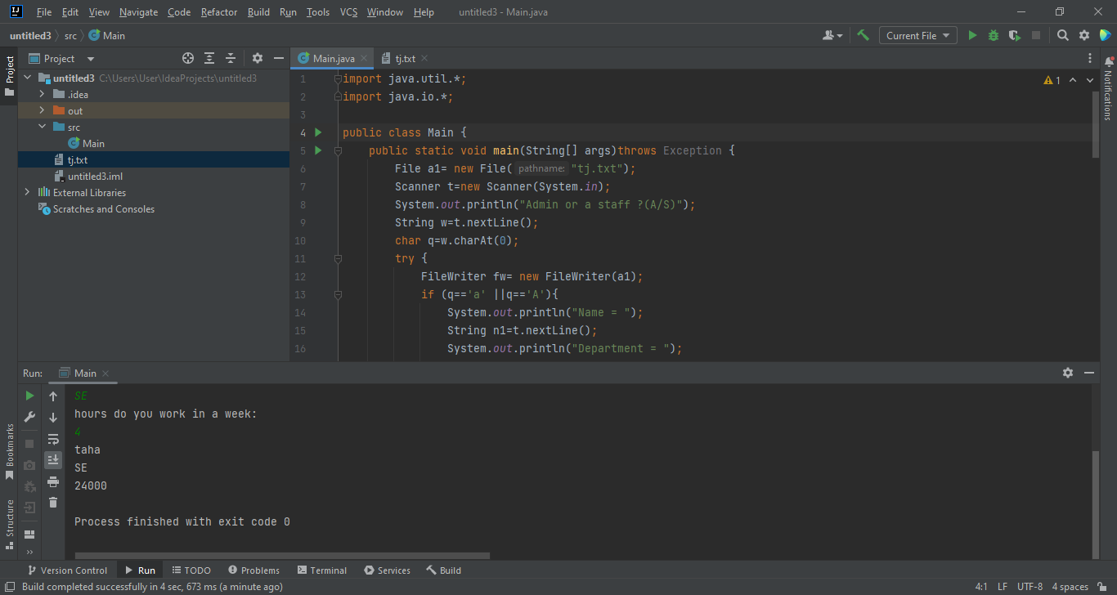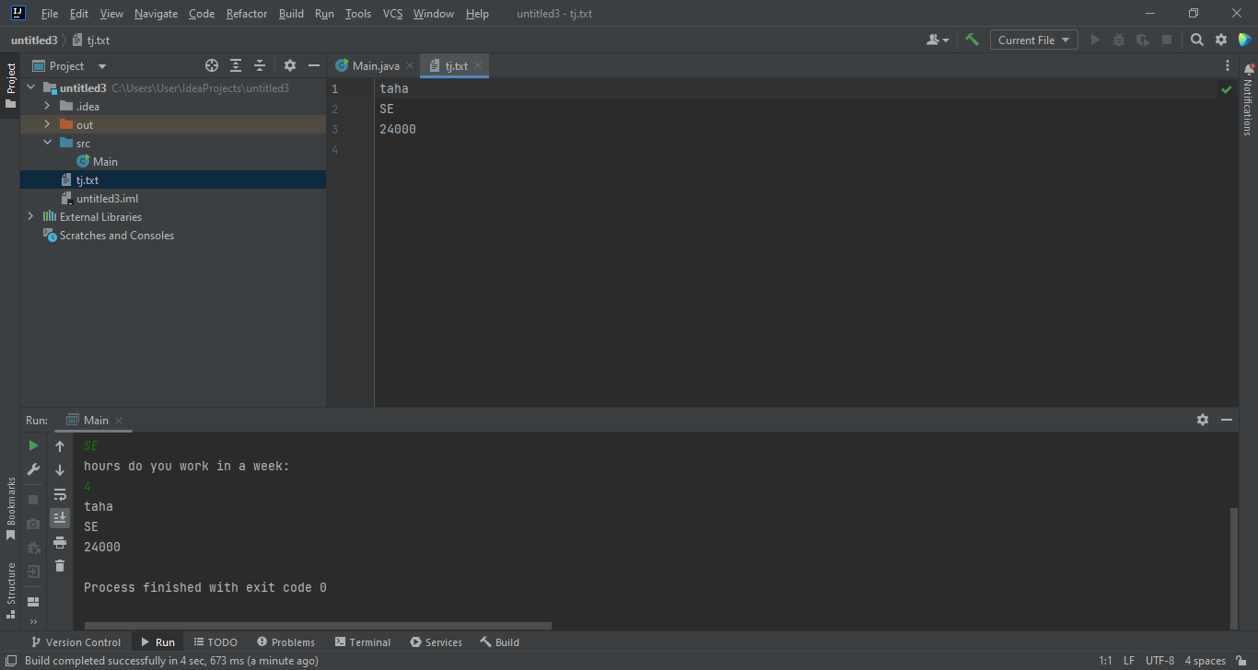

**Question 03:**

import java.util.*;

class Patient{

String id,n;

String d;

Scanner t=new Scanner(System.in);

void general(){

System.out.println("Name = ");

n=t.nextLine();

System.out.println("ID = ");

id=t.nextLine();

System.out.println("Did you visited the general doctor before?(Y/N)");

String result=t.nextLine();

if (result.charAt(0)=='y'||result.charAt(0)=='Y'){

info(n,id,1650-(1650*0.05));

}else {

info(n,id,1650);

}

}

void special(){

System.out.println("Name = ");

n=t.nextLine();

System.out.println("ID = ");

id=t.nextLine();

System.out.println("Did you visited the general doctor before?(Y/N)");

String result=t.nextLine();

if (result.charAt(0)=='y'||result.charAt(0)=='Y'){

info(n,id,2450-(2450*0.07));

}

else {

info(n,id,2450);

}

}

void info(String n,String i,double amu){

System.out.println("Name = "+n);

System.out.println("ID = "+i);

System.out.println("Amount = "+amu);

}

}

public class Main {

public static void main(String[] args)throws Exception {

Scanner q=new Scanner(System.in);

Patient a=new Patient();

Patient b=new Patient();

a.general();

b.special();

a=null;

b=null;

}

}

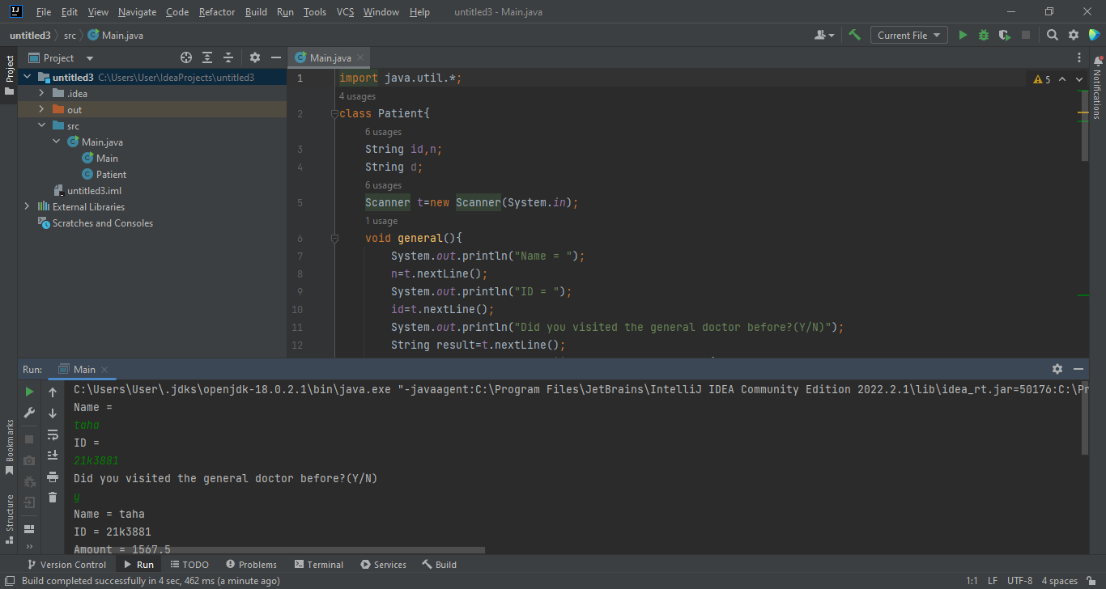

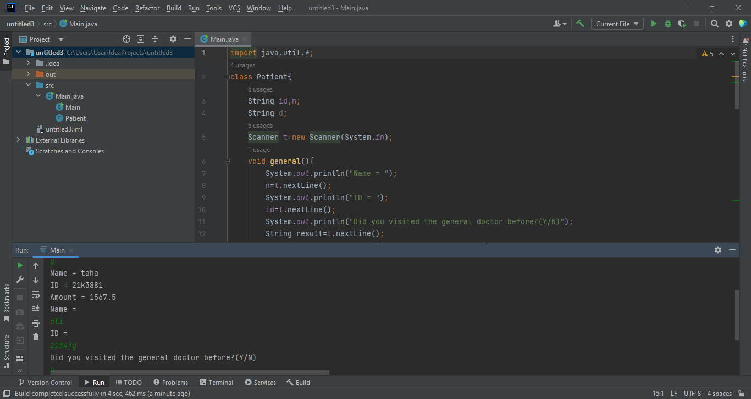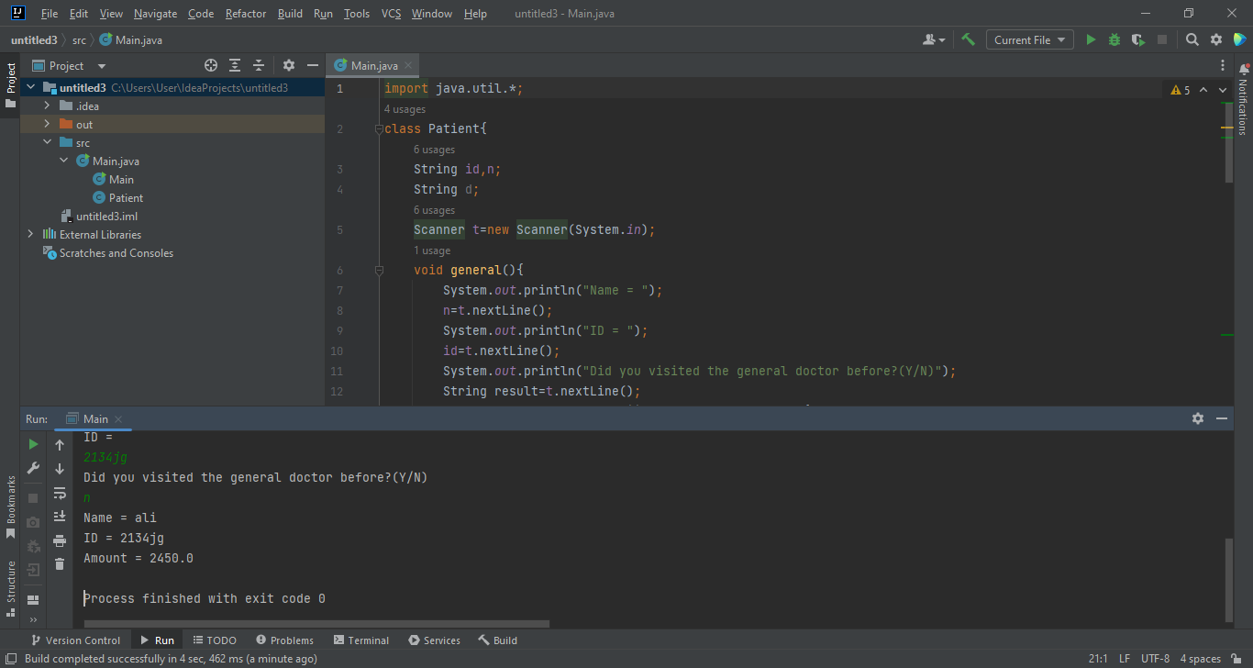

**Question 04:**

import java.util.*;

class Holiday{

String mon,n;

int d;

Holiday(String n,int d,String mon){

this.n=n;

this.d=d;

this.mon=mon;

}

boolean isSameMonth(String m){

if (m.equals(mon)){

return (true);

}else {

return false;

}

}

void display(){

System.out.println(n);

System.out.println(+d+mon);

}

}

public class Main {

public static void main(String[] args) {

Holiday a=new Holiday("Independence day",14,"August");

String ori_mon="August";

Holiday b=a;

b.n="Defence day";

b.mon="September";

b.d=6;

Holiday c=new Holiday("Labour day",1,"May");

a.display();

System.out.println(c.isSameMonth(ori_mon));

b.display();

System.out.println(c.isSameMonth(ori_mon));

c.display();

System.out.println(c.isSameMonth(ori_mon));

}

}

